Front End Web Lab Project 1

Using **no external JavaScript libraries or frameworks**, Build a simple tip calculator.

Narrative:

Provide a simple app that allows one to calculate an amount of a tip to apply to a bill.

Enter the total amount of the bill.

User selects 10%, 15%, 20% and it displays the amount that should be left as a tip, and a total to be paid (bill amount plus tip).

Optional Iteration 1:

Store the selected preferred tip amount in web storage and retrieve its value at application start.

Optional Iteration 2:

Add an option to add a custom tip amount.

Optional Iteration 3:

Make an option to split the bill *n* ways, showing the amount due for each person.

Optional Iteration 4:

Unit test all the application behavior.

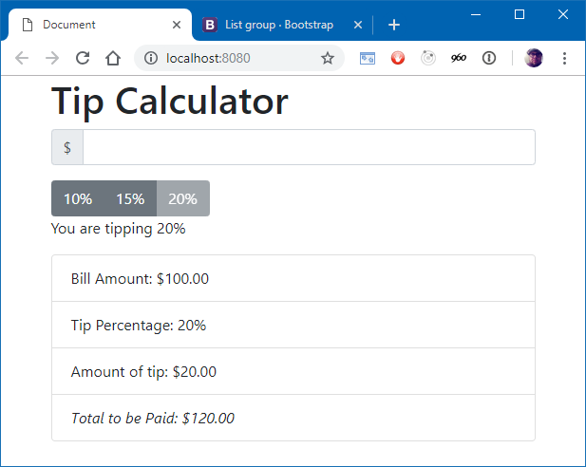

I have included a link to the bootstrap library in the index.html for styling. You can refer to the documentation at <http://getbootstrap.com>. (hint: I used a page-header component, an input group, and a list group for my example. Yours doesn’t have to be *exactly* like mine, but it is pretty rad.)

# Make it Work

Using the narrative at the beginning of this document, create the functionality of the tip calculator.

You must complete at least the basic functionality as described. There are also optional iterations if time allows.

Some tips:

* The button which indicates the selected tip amount should be disabled. The others should not.
* The input should be limited to numbers. If a number less than zero is indicated, make the border of the amount input red and clear out the calculated values in the list.
* Make sure you are formatting the output correctly.
* The calculated amounts in the list should update automatically as the user enters a value. No waiting for “enter”, no “do it” button.
* You can use the elements id property to identify meaningful elements. Please, no hooking to events in the HTML source.

# Deploy the Application

After you are happy with the application you have created, you can deploy it to the web.

Install the Zeit.co “now” command.

Stop your development server by issuing Ctrl+C in the command prompt window running your Webpack Development Server.

npm install -g now

Create a webpack build of your application by issuing the following command:

npm run build

A dist folder will be created in your project that has your HTML page and bundled JavaScript.

Change directory into the dist folder and issue the command to copy your application to the web, as follows:

PS C:\dev\lab1> cd dist

PS C:\dev\lab1\dist> now

You may be asked for your Zeit.co credentials that we set up in the classroom.

If successful, now will provide you a URL. Paste that URL into your browser’s address bar and behold your glorious work. Do a final check to make sure it is working correctly, then send a link to all your friends, your family. Print it out and put it on the refrigerator. But most importantly, provide it to your code reviewer and me. Send me an email at [jeff@hypertheory.com](mailto:jeff@hypertheory.com) with the subject of Front End Web Lab 100 Complete, and make sure you put your name in the email. Congratulations! See you in the 200 class!

If you need to make changes or fixes, simply run now again and you will be given a new URL.

# Rubric for Evaluating Code

As you build the application, try to apply and extend the concepts you learned in class. You will, most likely, have to do some extreme googling and research. Not everything you need to accomplish this lab was covered in the class. Your code reviewer will work with you to make sure your application is structured properly.